Карты

1. Базовая карта

<div class="card">  
  <div class="card-body">Basic card</div>  
</div>



1. Колонтитул, футер

<div class="card">  
  <div class="card-header">Header</div>  
  <div class="card-body">Content</div>  
  <div class="card-footer">Footer</div>  
</div>



1. Заголовки, текст, ссылки

<div class="card">  
  <div class="card-body">  
    <h4 class="card-title">Card title</h4>  
    <p class="card-text">Some example text. Some example text.</p>  
    <a href="#" class="card-link">Card link</a>  
    <a href="#" class="card-link">Another link</a>  
  </div>  
</div>

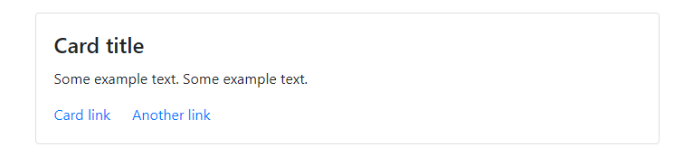

1. Карты изображений

<div class="card" style="width:400px">  
  <img class="card-img-top" src="img_avatar1.png" alt="Card image">  
  <div class="card-body">  
    <h4 class="card-title">CSS</h4>  
    <p class="card-text">Some example text.</p>  
    <a href="#" class="btn btn-primary">See Profile</a>  
  </div>  
</div>

Пример

<div class="container">

<h2>Card Image</h2>

<p>Image at the top (card-img-top):</p>

<div class="card" style="width:400px">

<img class="card-img-top" src="img_avatar1.png" alt="Card image" style="width:100%">

<div class="card-body">

<h4 class="card-title">CSS</h4>

<p class="card-text">Some example text some example text. John CSS is an architect and engineer</p>

<a href="#" class="btn btn-primary">See Profile</a>

</div>

</div>

<br>

<p>Image at the bottom (card-img-bottom):</p>

<div class="card" style="width:400px">

<div class="card-body">

<h4 class="card-title">HTML</h4>

<p class="card-text">Some example text some example text. Jane Doe is an architect and engineer</p>

<a href="#" class="btn btn-primary">See Profile</a>

</div>

<img class="card-img-bottom" src="img_avatar6.png" alt="Card image" style="width:100%">

</div>

</div>

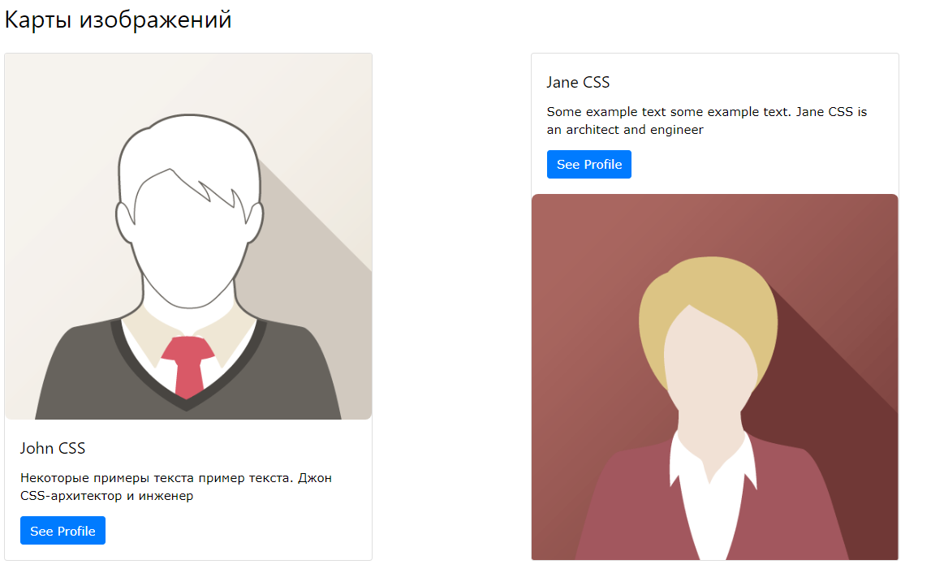

1. Наложение.

Пример

<div class="container">

<h2>Card Image Overlay</h2>

<p>Turn an image into a card background and use .card-img-overlay to overlay the card's text:</p>

<div class="card img-fluid" style="width:500px">

<img class="card-img-top" src="img_avatar1.png" alt="Card image" style="width:100%">

<div class="card-img-overlay">

<h4 class="card-title">John CSS</h4>

<p class="card-text">Some example text some example text. Some example text some example text. Some example text some example text. Some example text some example text.</p>

<a href="#" class="btn btn-primary">See Profile</a>

</div>

</div>

</div>

